

**Soi Aroylatics**

COR1305

Spreadsheet Modelling and Analytics

G7 Team 2

AY 2019-2020 Term 2

|  |  |  |
| --- | --- | --- |
| **Name** | **Student ID** | **Email** |
| Lim Li Yao | 01359331 | liyao.lim.2018@business.smu.edu.sg |
| Melissa Anna Dittmer Jia Xin | 01371563 | madittmer.2018@socsc.smu.edu.sg |
| Tan Jie Ying | 01371293 | jieying.tan.2018@accountancy.smu.edu.sg |
| Tan Qiu Long Matthew Ian | 01328522 | matthew.tan.2018@sis.smu.edu.sg |
| Tan Yin | 01331040 | yin.tan.2018@sis.smu.edu.sg |

|  |
| --- |
| **1 ABOUT THE COMPANY** |

Soi Aroy is a Singapore-based food and beverage business, focusing on Thai cuisine. There are currently two branches, one operating in Sim Lim Complex and the other in SMU’s campus. Both branches’ operations began in 2018 and 2019 respectively. Soi Aroy has received significant media coverage and has been featured in multiple well-known newspapers in Singapore.

|  |
| --- |
| **2 PROJECT SCOPE** |

**Methodology**

To improve the current business using modelling and optimisation functionalities in Microsoft Excel. Necessary sales, cost and information on marketing events will be provided by the company. Information on external events in SMU and other proxy data will be retrieved from publicly accessible domains.

|  |  |  |
| --- | --- | --- |
| **ISSUES** | | |
| * Has been making a loss since the beginning of operation * Owner noticed that he has exceptionally high costs relative to other similar sized F&B outlets * Especially low sales volume during certain periods of the year, particularly university holiday periods for both branches * Current marketing and promotional events are ineffective in improving sales * Owner is uncertain of how to capitalize on events held in or nearby SMU which provide a surge in foot traffic * Lack of foresight on future sales and unable to plan accordingly | | |
| **SOLUTION** | **METHODOLOGY** | **PURPOSE AND BENEFITS** |
| Investigation into new brand and marketing strategies and profit maximization recommendations | Cost minimization using Excel solver based on different calculated parameters.  *\*Note that because we assume the PED of Soi Aroy’s products to be elastic, we will not be recommending raising prices.* | Provide the business owner with multiple ways to reduce costs.  *\*We recognise that there are some cost centers that the owner would not want to decrease. (e.g. manpower)* |
| Forecasting of sales based on seasonality trends, marketing schemes and profit maximization options | Projection of sales using the trendline function and TREND() function (if trendline is linear), taking into account different parameters as stated previously.  Appropriate visualisations will be used to convey the results obtained through the forecasting process. | To empower the business owner of future sales to plan future inventory.  To understand the effectiveness of current and future brand and marketing strategies.  To understand the additional profit gained from different profit maximization options. |

|  |
| --- |
| **3 INFLUENCE DIAGRAM** |

In the subsequent sections of the proposal, the following legend will be used to represent the input and output values required in the influence and black box diagram.

|  |  |  |
| --- | --- | --- |
|  | **Legend** |  |
| Input | **Decision** |  |
| **Parameter** |  |
| **Historical** |  |
|  | **Intermediate** | Output |
|  | **Result** |
|  | **Key Result** |

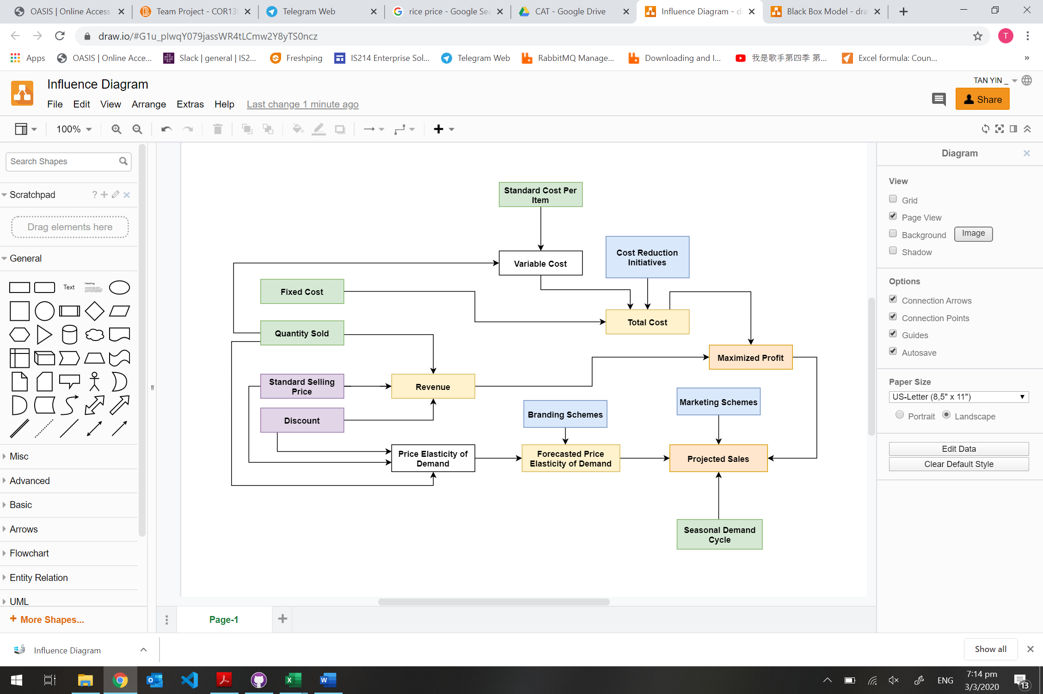

|  |
| --- |
| **4 BLACK BOX MODEL** |

